Cinekid presents the selection for the 10th anniversary of Script LAB

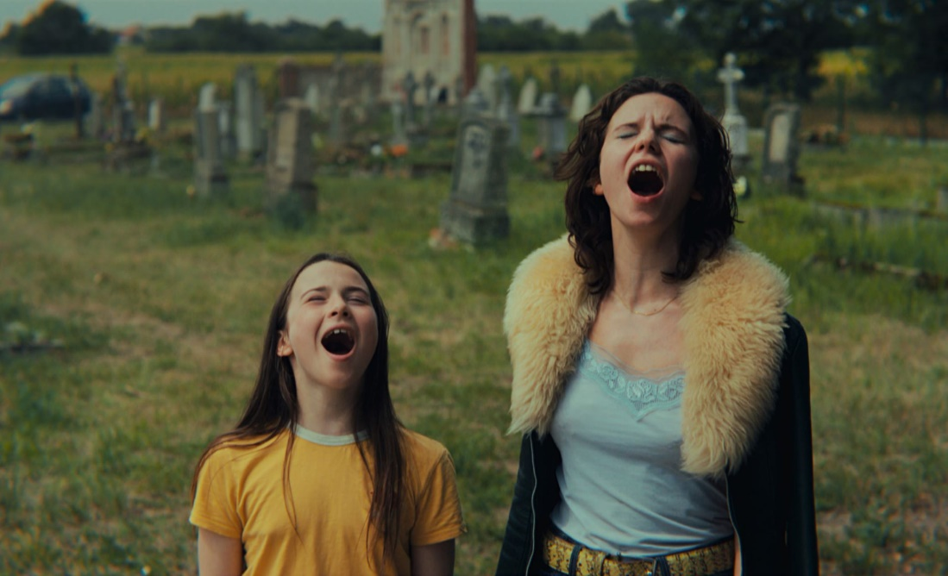
The still shown above is from the film Kiddo, which was part of the Cinekid Script LAB 2020-2021 and Directors LAB 2022 selections and will feature in special screenings during Cinekid Festival throughout The Netherlands.

Amsterdam, July 6, 2023 - Cinekid marks ten years of Script LAB with thirteen projects in development, representing ten different production countries. The six-month talent development programme supports screenwriters working on a film or series script for children, starting at Cinekid for Professionals (Amsterdam, October 2023) and wrapping up during the Berlinale (Berlin, February 2024). Eighteen writers will participate under the guidance of their coach and peer writer(s).

As well as many new faces, Cinekid is delighted to welcome back three alumni to the LAB: Julia Andersen and Torfin Iversen (The Kicksled Choir) and Eva Keuris (Bizarre). They will be joined by fifteen writers with a diversity of experience in screenwriting for children’s productions. The overall selection includes two animation projects and eleven live-action projects.
The possibility of participating in the LAB with a series remains popular after introducing it last year. Three series will be developed in this edition: Cherry & Zucchini, written by Alexandros Rellos from Greece; My Mother Always Says..., written by Annick de Wolf from The Netherlands; and Wacky Tales, written by Raphaëlle Tinland from France.
There was an increase in the number of submissions targeted at the pre-teen age group. The Netherlands, Belgium, Iceland and Norway each contribute two projects, respectively, marking the strong infrastructure of the children’s media sector in the Nordic and Benelux regions.
Cinekid is proud to support children’s projects from Eastern Europe, granting scholarships to Atlas of the Universe, written by Mihai Mincan and Paul Negoescu from Romania, Bulgaria and the Czech Republic, and Sylphs, written by Rositsa Dobreva and Lachezar Velinov from Bulgaria.
Cinekid takes pride in marking the 10th edition of the Script LAB this year. Over the years, 110 projects and 140 participants from 32 countries have participated. In the last year, LAB alumni have premiered their projects in Berlinale’s Generation strand, including Kiddo, written by Nena van Driel and Zara Dwinger (Script LAB 2020/21), and Sea Sparkle, written by Domien and Wendy Huyghe (Script LAB 2018/19). Snot & Splash, written by Ilja Rautsi, has just been announced as part of the Locarno Kids programme. These are only a handful of festival hits that have been developed in the LAB.
Sara Juričić (Head of Cinekid for Professionals) comments: “The value of the Script LAB for developing children’s content is unmeasured. We are proud to have been involved in numerous children’s productions that have made their way to the hearts of thousands of children. This year, three projects were developed through the Script LAB, premiering at major film festivals such as Berlinale and Locarno, with more to be announced. These successes prove the urgency and longevity of the LAB, something that would not be possible without our partners' great support and trust.”
Esther van Driesum (Head of Studies, Cinekid LABs) comments: “Over the last ten years, the selection process for the Script LAB has become increasingly challenging because of the growing number of applications, their quality and intellectual acuity. This application round for the upcoming LAB was no different; we received an interesting mix of backgrounds in terms of discipline, age, culture and level of experience. Alumni also applied, which shows that the programme is worth repeating.”

About Cinekid Script LAB
Cinekid Script LAB provides participants with the opportunity to work on their children’s film or series in development under the guidance of internationally acclaimed coaches and with the support of their peer writer(s). The coaches offer the participants bespoke guidance, addressing the needs of both the writer and the story during the LAB’s two-part trajectory. On top of this, participants receive valuable networking opportunities at two world-leading industry events for children’s media: Cinekid for Professionals and the Berlinale. Team building and the interpersonal exchange of ideas and experiences within a safe and nurturing environment are the foundation stones of Cinekid Script LAB.

Cinekid Script LAB is funded by the Creative Europe MEDIA programme and is organised with the support of the Athens International Children’s Film Festival, Finnish Film Foundation, Flanders Audiovisual Fund, Icelandic Film Centre, Netherlands Film Fund, Norwegian Film Institute, and the Swedish Film Institute.

More information on Cinekid Script LAB can be found on cinekid.nl.

Full list of participating projects and writers:

3,5% (film/live-action)
Participating writer: Malin Marmgren
Nominated by: Swedish Film Institute

Atlas of the Universe (film/live-action)
Participating writer: Paul Negoescu
Produced by: deFilm (Romania)

Bizarre (film/live-action)
Participating writers: Eva Keuris, Jelle Nesna
Produced by: Rinkel Film (The Netherlands)
Nominated by: Netherlands Film Fund

Brie and the Olm Cave (film/live-action)
Participating writer: Astrid Bode
Produced by: Lunanime (Belgium)
Nominated by: Flanders Audiovisual Fund

Cherry & Zucchini (series/live-action)
Participating writer: Alexandros Rellos
Produced by: Rourou (Greece)
Nominated by: Athens International Children’s Film Festival

Dead Disa (film/live-action)
Participating writer: Gunnar Theodór Eggertsson
Produced by: Go To Sheep (Iceland)
Nominated by: Icelandic Film Centre

My Mother Always Says... (series/live-action)
Participating writer: Annick de Wolf
Produced by: Fiction Valley (The Netherlands)

Stairway to Heaven (film/live-action)
Participating writer: Martha Antonette Solli, Trond Morten Venaasen
Produced by: Fabelaktiv AS (Norway)
Nominated by: Norwegian Film Institute

The Kicksled Choir (film/live-action)
Participating writers: Julia Andersen, Torfinn Iversen
Produced by: Fjordic Film (Norway)

Sylphs (film/animation)
Participating writers: Rositsa Dobreva, Lachezar Velinov
Produced by: Zographic Films (Bulgaria)

Thelma and Rafaël (film/live-action)
Participating writers: Martine Decroos, Dominique van Malder
Produced by: De Wereldvrede (Belgium)

The Big Snow (film/animation)
Participating writer: Clarisse Charrier
Produced by: Tulipop Studios (Iceland)
Nominated by: Icelandic Film Centre

Wacky Tales (series/live-action)
Participating writer: Raphaëlle Tinland
Produced by: Ikki Films (France)

END

Note to editors, not for publication
For interview requests, accreditations, or questions:
Cinekid
Sara Juricic – Head of Cinekid for Professionals
Jessica Cohen – Cinekid for Professionals coordinator
professionals@cinekid.nl

PR and communication agency De Wolven
Annabella Rijksen
annabella@dewolven.com
+31 6 42 54 85 63
+31 20 620 3354

About Cinekid
Cinekid wants to amaze, entertain, connect and contribute to the development of children into independent, conscious and right-minded global citizens. To achieve this goal, Cinekid presents, produces, teaches and communicates with, by and about film and moving images in languages that reach children. But Cinekid is also an international platform focussing on children’s film productions in order to boost the range and quality of film productions and to connect the industry. The Cinekid Festival takes place from 13 through 31 October across the Netherlands. For the complete programme, go to cinekid.nl. Follow the latest Cinekid news on Facebook, Instagram and via the Cinekid newsletter.
Cinekid Festival 2023 takes place during autumn holidays across the country from October 15 to 29, 2023, with Pathé Amsterdam Noord as the main location. Here you will also find the largest Cinekid MediaLab: a whopping 1000 m2. The lab is open to the public from Saturday, Oct. 21 to Friday, Oct. 27. There are also eight national theatres that are 'satellite locations' with their own MediaLab.
Cinekid for Professionals (CfP) will take place October 24-27, 2023. Are you attending CfP as a guest? You can find more information here.
The Cinekid schools program will take place from October 16-20, 2023, at Pathé Amsterdam Noord.

